Name: Akshat Bhargava
Rollno: BEAD-22563
DMV Practical 7
Problem Statement: The goal is to interact with the OpenWeatherMap API to
retrieve weather data for a specific location and perform data modeling and
visualization to analyze weather patterns over time.

1. Register & Set API Key
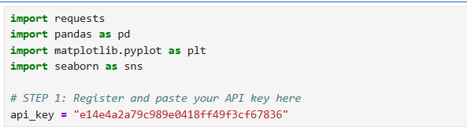

2. Retrieve Weather Data for Location
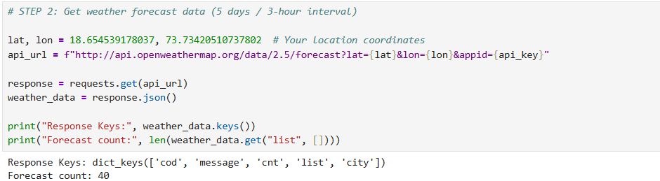

3. Extract Temperature, Humidity, Wind, Weather Description
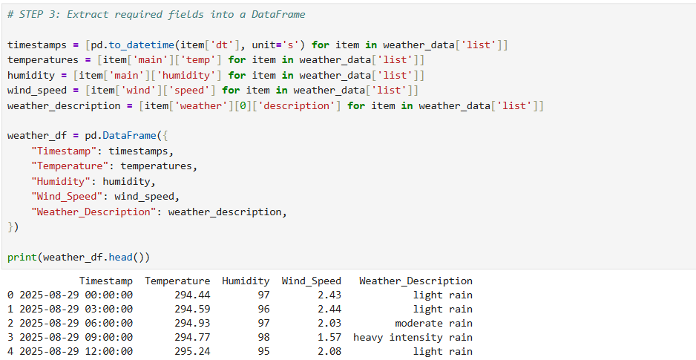

4. Clean & Preprocess Data
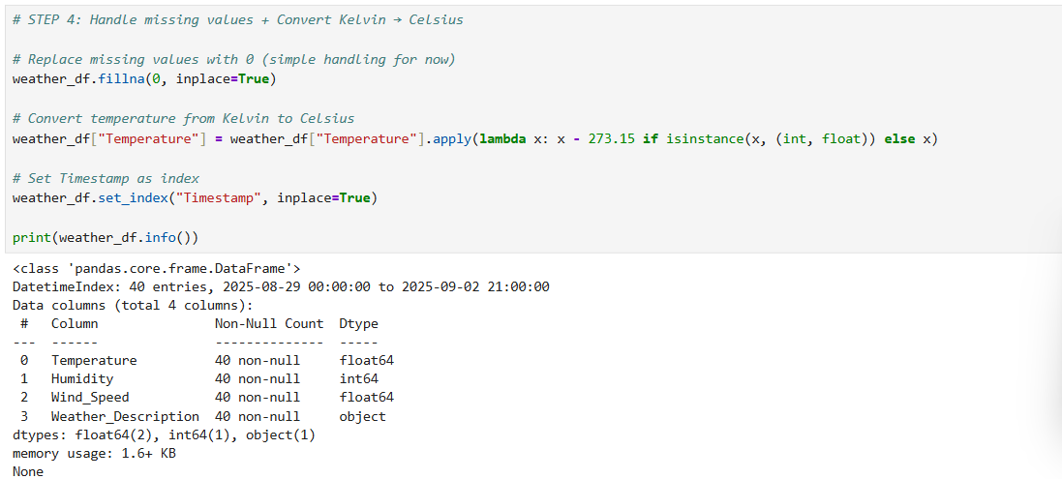

5. Data Modeling (Min/Max/Average)
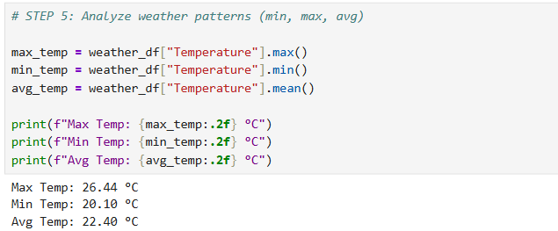

6. Visualization (Temperature, Humidity, Wind)
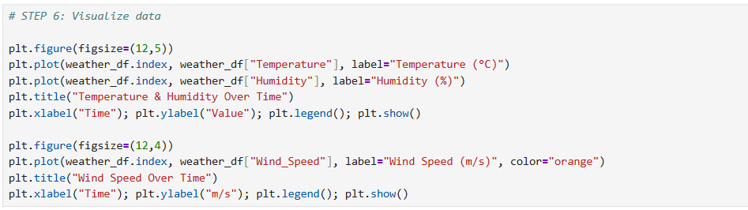
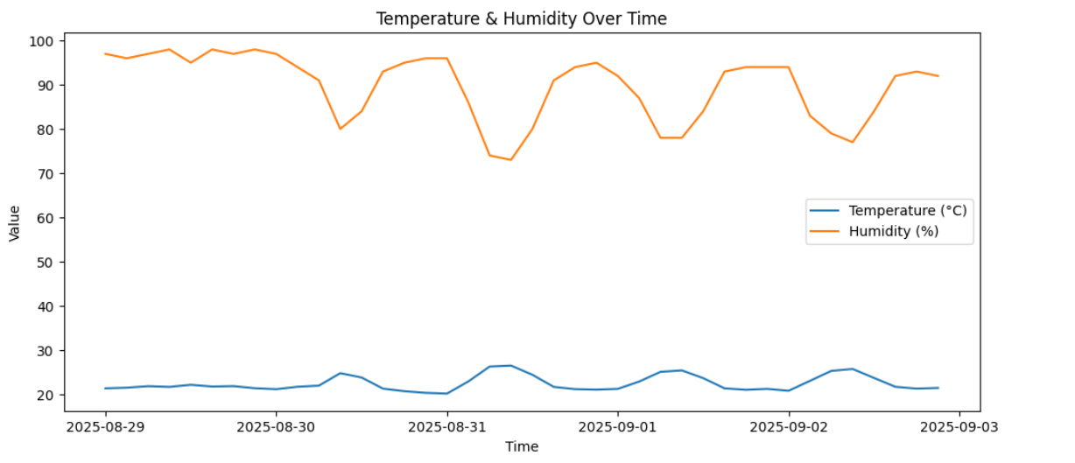
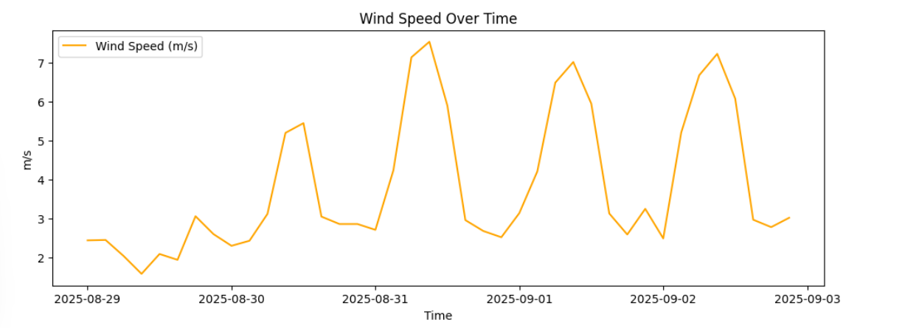

7. Data Aggregation (Daily Stats)
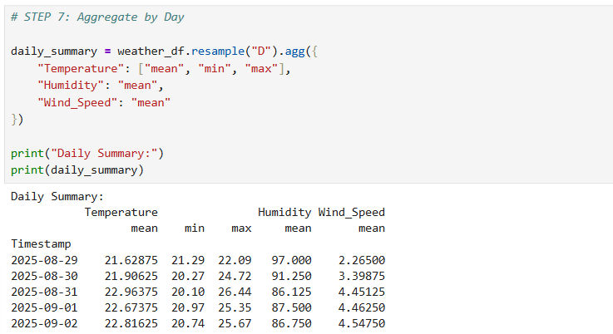

8. Explore Relationships (Correlation Heatmap)
